**SMART MONITORING OF INFANT INCUBATOR**

**Node Red:**

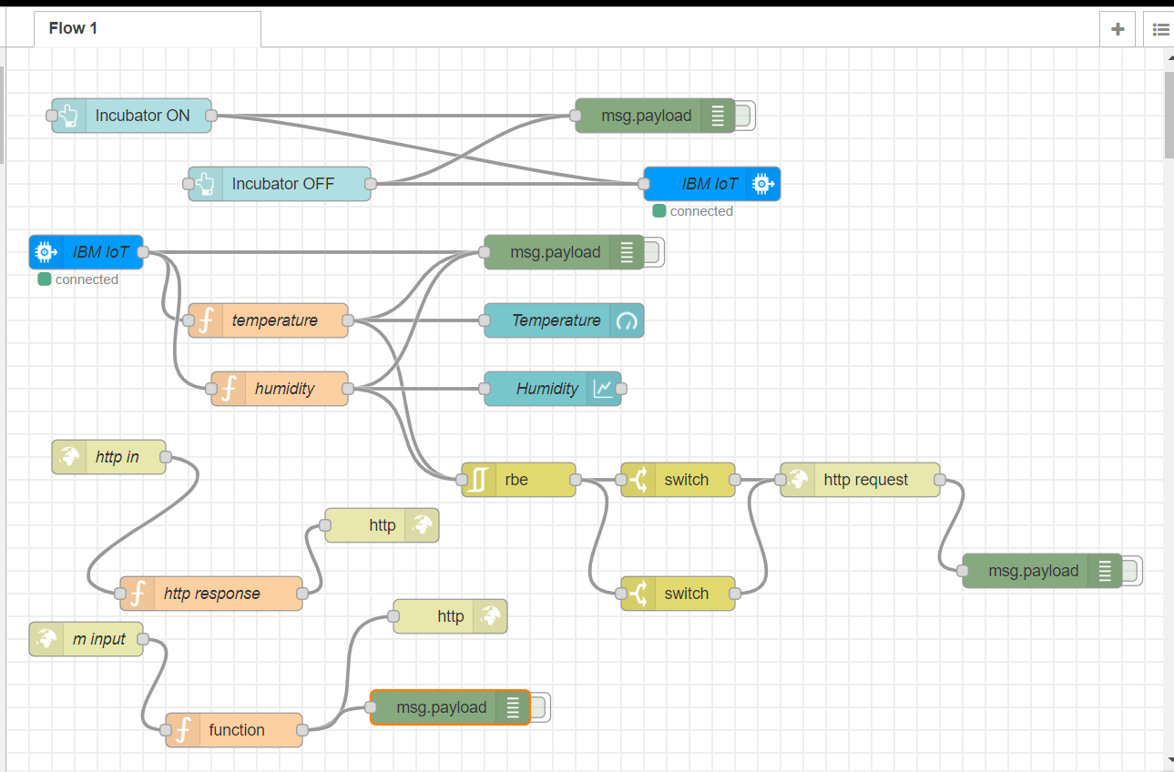

**MIT APP INVENTOR:**

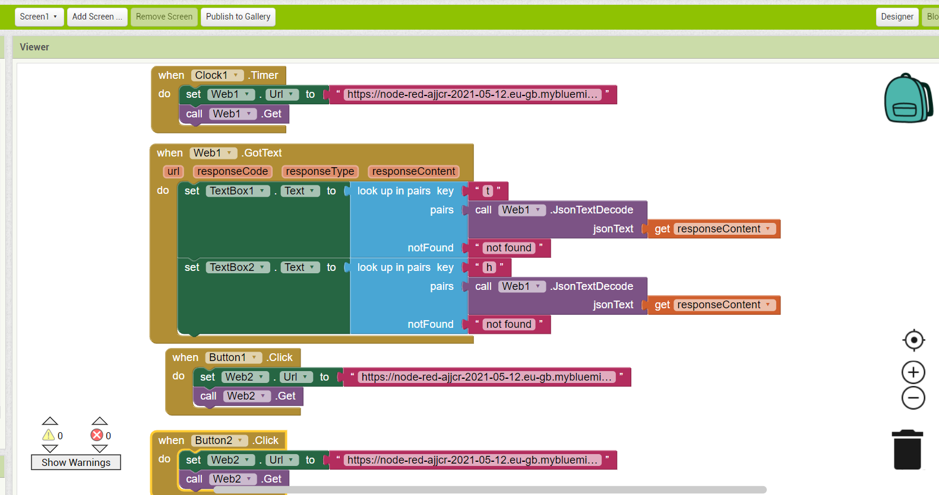

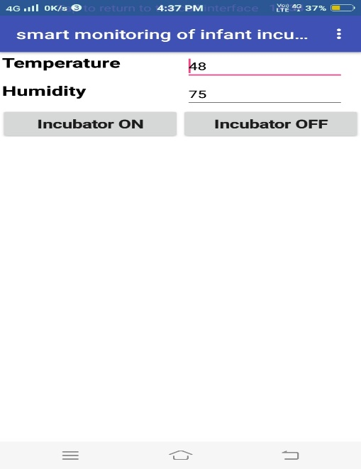

**WEB APPLICATION:**

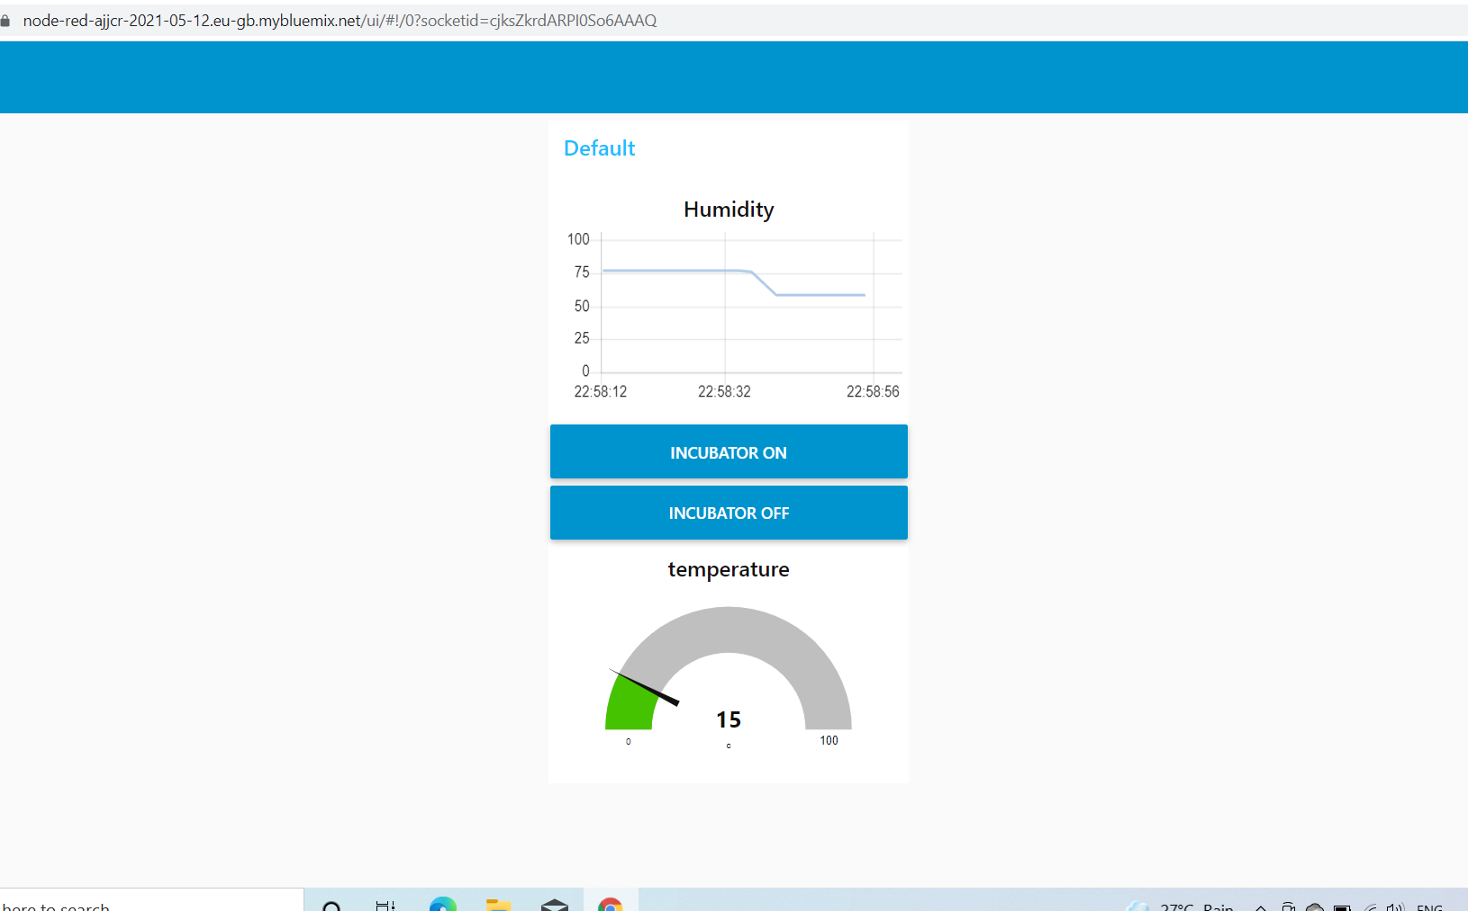

**PYTHON OUTPUT:**

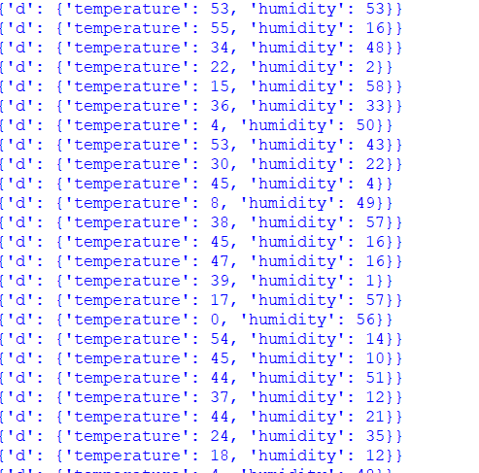

**URL OF SENSOR DATA:**

<https://node-red-ajjcr-2021-05-12.eu-gb.mybluemix.net/sensordata>

**URL OF WEB APPLICATION :**

<https://node-red-ajjcr-2021-05-12.eu-gb.mybluemix.net/ui>

**URL OF DATA:**

<https://node-red-ajjcr-2021-05-12.eu-gb.mybluemix.net/data?command=Incubator%20OFF>

<https://node-red-ajjcr-2021-05-12.eu-gb.mybluemix.net/data?command=Incubator%20ON>

URL FOR MESSAGE NOTIFICATION:

<https://www.fast2sms.com/dev/bulkV2?authorization=EoIBwl0cgDaCvuJ3Yk2jPUWRKhXzqMsmAbZ9y6xdOtiL7Hpre1KuLf8NAFo6cG9H5xSbDR7m4UPwjp1s&message=HIGH&language=english&route=q&numbers=7093939767>

URL OF APK FILE:

<http://ai2.appinventor.mit.edu/b/27xb>